Some Key Issues for Public Policy on Non-State Providers
Background Note for the
Global Education Monitoring Report (GEMR) 2021

Keith M Lewin.
Professor of International Development and Education,
University of Sussex

The GEMR 2021 seeks to explore key issues in the debates around the role of non-state actors in the achievement of global education targets and the nature of non-state actors. This narrative responds to the GEMR 2021 Concept Note and identifies several key issues that are likely to be important in going forward.

This discussion has a bias towards those areas that are under researched. It does not pretend to be comprehensive and cover the range of NSPs engaged in service provision of different kinds. It seeks to draw attention to some gaps in the literature and evidence. It builds on ideas in Lewin 2017 and Lewin 2014 and complements the recent WEB contribution on rethinking the role of NSPs. Three issues are highlighted – the need for a taxonomy and operational definitions of NSP types, the issues of interaction between public services and NSPs, and the motives of actors and owners and managers of assets. Four other clusters of concerns invite further consideration. These include evidence of scalable innovation in learning in NSPs, insight into staff and student turnover and institutional volatility, sustainable financing of NSPs including costs to government and to households, and the risks associated with curating data on NSPs.

- Definitions and a Taxonomy of Providers

Non state providers deliver educational services in many countries. They have many different forms of ownership and organization, and different motives for engagement. Any discussion about the role of non-state actors is actually a collection of different discussions about different forms of providing educational services with different forms of beneficial ownership, management, teacher employment, financing and different prioritisation of educational, social, economic and cultural goals for learning. “Non State Providers” (NSP) group together very different organisations under the same umbrella. Problems of definition are central to policy dialogue.

Non-State Providers (NSPs )is problematic as a category itself since it suffers from the obvious weakness that it depends on a negative. Defining things by what they are not begs many questions about whether it is confusion or shyness about the criteria that would allow a positive definition of specific types of NSP. As a catch all category NSP invites confusing mixes of responsibilities, liabilities, beneficial ownership, transfer pricing, tax domicile ambiguities, and exclusionary and rivalrous practices. It has become common to mix not-for-profit institutions with for-profit providers of services with non-transparent underlying ownership.

Simple dichotomous oppositions that juxtapose the “private sector” with public provision mislead. The private sector is not the symmetrical counterpoint of the state. It has many different players with different motives, vastly different scales of activity, and unclear accountabilities. It has no necessary commitment to deliver educational services, promote equity, or reduce poverty. It may be global or local or anything in between. States have citizens, civil service bureaucracies, legal systems and contract law, security forces and rights based obligations and finance and manage national education systems . NSPs have none of these things. In summary NSPs include many different actors operating in different educational markets without a common purpose. There is thus not a simple binary division, or a uni-dimensional role, that distinguishes between public (state) and non-state (private) providers of educational services.

The first challenge for the GEMR is to unpack the characteristics of NSPs and agree a taxonomy that can be used analytically. The Concept Note rightly recognizes the centrality of getting beyond over simple definitions noting that “a commonly accepted typology has not been agreed”. Repeated observations about the difficulties and ambiguities in practice need to be translated into an operational useful set of distinctions and an analytically coherent dimensions that can be mapped empirically. If this can be linked to different theories of education and development that uncover the value based choices and assumptions that drive the political economy of policy on public and private goods and the roles of NSPs so much the better. The debates around public and private investment in education are largely uniformed by theories of change that unpack the causal assumptions of protagonists for different architectures of service delivery. More testable propositions are needed that can be empirically tested.

- Interaction of Public and Private.

Very little systematic research exists exploring how NSPs interact with public provision. This is true at all levels of analysis. At the macro level, the image of a complementary contribution whereby NSPs enhance access to education is widely promoted but may not be accurate. Public Private Partnerships (PPPs) are rarely subject to detailed pre and post hoc analysis. It is often unclear whether such arrangements deliver on the promises made by their advocates and whether they represent value for money. Recent prominent collapses of very large scale PPPs in the UK indicate lack of transparency in the terms of the partnership are, the extent to which contracting parties are actually making proportionate contributions to finance, the assumptions on which debt is contracted, and the extent to which risk is actually shared on the downside.

The role of lenders technical advisors (LTAs) has also been questioned when it appears that most of the protections and de-risking have been used to protect lenders not the interests of borrowers. Some not-for-profit NSPs appear to register as charities but make use of service fees and other transfers to sister companies that share the same beneficial ownership. As with Private Finance Initiatives (PFIs) it is often unclear who benefits by how much when things go well and who backstops losses and liabilities when they do not. This is even more difficult to ascertain when transactions are cross border and may involve transfer pricing, currency risks, and non-domiciled private sector holding companies. Since PPPs and PFIs have existed for several decades there is now a substantial empirical trail to be reviewed. This includes several national audit reports in different countries including well regulated jurisdictions like the UK. A critical review is needed to establish whether what is claimed about the benefits of PPPs and PFIs is actually evidentially true for low income countries with external partners.

At the meso level of institutional development and service provision, private for profit NSPs have every incentive to establish fee paying schools and educational service companies to access markets that can generate surplus income and good rates of return for owners and shareholders. In the case of private schools these are likely to be concentrated in geographic locations which are already well served by established public educational institutions since this is where there is likely to be most disposable income. There is a risk that NSPs may hollow out state schools of the most capable students and teachers in richer locations on the promise of marginal gains in performance on high stakes examinations. This kind of competition has costs on the downside that are rarely recognized. Interactions between NSPs and state providers can be constructive but need to be managed to avoid destructive competition.

At the micro level of the household many studies show that poverty is the most powerful excluder from school and one of the best predictors of achievement and attainment. The direct and indirect costs of NSPs are often unknown, as is the relationship between prices and costs. Price is critical to determining which households can afford to attend which school, especially at post primary level. NSPs can be non-transparent about the totality of the fees and other charges they actually levy. If they are private companies their costs are likely to be regarded as a commercial secret. Even more unknown and rarely discussed is how poor households finance costs. Charging fees to households below the poverty line for public goods increases the number of households below the poverty line. Borrowing from traditional sources of credit (e.g. rural money lenders, high cost micro-credit facilities) creates a kind of double jeopardy – the debt is sub-prime to start with and repayments are cumulatively unaffordable with interest rates that are often over 100% annually. The risks are compounded where the lending institution is also connected to the service provider. The price of schooling to households in public schools can set a floor to charges in NSPs seeking to provide similar services. Scholarship programmes that provides cash transfers may also set the price for private tuition funded from the scholarship money. These kind of cash transfers have an opportunity cost since they are targeted at individual households rather than investment in improved quality of schooling.

For-profit providers are unlikely to target the poorest communities or the most marginalized unless they have methods to de-risk their investment, limited exposure to losses, and low start up and exit costs. If so they may end up being more expensive than the direct delivery of public services. If NSPs really do chose to locate to serve unserved poor populations, and can do so in a cost effective way for themselves, this could provide a disincentive for public authorities to deliver rights to fee free education to the most marginalised. Philanthropic contribution is never large enough or reliable enough to finance systemic solutions to problems of financing universal access and system level quality improvement.

The second challenge is therefore to explore the many possible patterns of interaction between public systems and NSPs. This has many dimensions that include:

- Local competition within overlapping school catchment areas for the most capable and richest students
- Unbalanced social exclusions where NSPs serve particular communities and not others in the same area
- Competition for contributions from parents and communities to school funds and facilities which may favour NSPs and make it more difficult for public schools to raise funds
- Manipulation of who is entered for high stakes examinations to maximize pass rates by selecting out those who will fail and discouraging exam entry by those not likely to score highly
- Exclusion of students with behavioural issues and special needs from NSPs on the expectation that public schools will pick up obligations to rights to education
- Growth in shadow schooling and private tuition fueled by selective entry NSPs
- Local competition for teachers between NSPs and public schools
- Pressure to share publicly funded CPD, curriculum development, teacher education etc with NSPs that may or may not pay tax or contribute to the funds needed for professional development
- Lack of information on patterns of interaction between public systems and NSPs and absence of any methods to manage constructive and destructive dynamics.

- Motives and NSPs

Public goods can only be guaranteed by public authorities. Staff in NSPs may be motivated to contribute to the delivery of public goods but there is no necessary obligation on them to do so. Some NSPs clearly do not have clear affiliation to public goods and are marketed in ways which to stress the private benefits to individuals of attendance. Most for-profit NSPs are explicit about this. Other types of NSPs may project commitments to public goods, pro-poor bursaries, outreach programmes et al. that do complement public provision. Formally if the NSP institutions are rivalrous and exclusive, rather than non-rivalrous and non-exclusive, they are promoting private rather than public goods.

Motives may be best judged from behaviours more than mission statements. Patterns of admission, marketing, outcomes, financing, and governance and beneficial ownership are more indicative than unsubstantiated rhetorical claims. NSPs may reinvest profits and appear to be motivated by ethical, religious, or altruistic beliefs and commitments. If the purpose of reinvestment is to increase market share and raise margins on capital invested in fixed costs then the drivers are private rates of return rather than public benefit.

NSPs that operate selection criteria for students and have operating practices that exclude those with low levels of achievement, poor behaviour, and inability to pay direct and indirect costs can only have very limited contributions to increased access to education whatever their prospectus may say. In many countries there is no reason why NSPs that do not receive public money should promote public goods or national development, rather than seek private goods and personal development. One test is to establish the magnitude of contributions that may enhance access relative to needs e.g. scholarship programmes, fee waivers, outreach programmes, and access partnerships with schools in deprived areas.

The motives of owners and managers of NSPs may not necessarily mirror those of parents and students. It is an empirical question what the motives are for different NSPs as institutions, how these map onto the motives of their staff, and how these resonate with their constituencies of stakeholders. The organizational culture of remuneration and rewards may signal different types of motive and engagement but is rarely discussed or researched. Various versions of “payment by results” and Education Outcomes Funds” that defer a proportion of payments until results have been achieved may be more about ensuring guaranteed rates of returns on investment than about a long term commitment to public goods. Organisations that enforce non-disclosure agreements on employees signal unhappiness with disclosure of working practices and rights of employees to share good practice within the teaching profession.

The third challenge is that motives and ambitions of staff of NSPs, and their institutional culture, may differ radically from those of local and national education authorities. National development and commitments for universal achievement of minimum learning goals are appropriate for public authorities but are not the competence of small scale providers with other kinds of stakeholders. Apparently more altruistic goals (e.g. promoting global citizenship SDG 4.7), are in tension with the ambition of students and parents to succeed in high stakes selection examinations that have more losers than winners. High rates of return to beneficial owners may co-exist with public goods but are much more likely to be associated with private returns ton favoured groups.

An assumption behind the engagement the SDGs anticipate with NSPs seems to be that somehow NSPs staff are motivated to contribute to the achievement of SDGs, or at the very least are not minded to frustrate the ambition of the SDGs by their actions, whether intended or unintended. Some NSPs, and some different groups of stakeholders see investment in education as a positional good whose value lies in having more of it of a higher quality than others. Profiling the motives of NSP staff and their management cultures is central to understanding the role the NSPs can and do play for equitable educational development.

Four areas needing more research and empirical mapping:

- Innovation

There are many claims that NSPs and particularly private fee paying providers are innovative in their pedagogy, curriculum and learning outcomes. These claims have to be balanced against a lack of systematic evidence that supports such assertions. They also have to be balanced by lack of visibility in most systems that innovations in the private sector have been mainstreamed into mass public systems. There are several key questions. Is there proprietary knowledge that improves achievement and attainment that is not available in the public domain? If so what prevents is being replicated? If there are scalable innovations operating effectively in NSPs why have they not diffused across systems over the last 50 years? If the innovations were successful in producing valued outcomes e.g. enhanced examination results, then they would diffuse across education systems over time. There is scant evidence that this happens on scale.

One reason for lack of diffusion may be that NSPs that market themselves as maximizing results on conventional high stakes examinations may not in fact be innovative pedagogically. They may be using tried and tested whole class teaching, recall based drilling, examination cramming, high levels of time on task, and powerfully didactic pedagogies. This is likely to be especially the case in “second chance” systems that provide private tuition to those who fail examinations first time around. It may also be typical of paid private tuition in shadow systems of additional classes before and after school hours. These are not generally characterized by pedagogic innovation but by repetitive cramming of examination relevant knowledge. They can add considerably to costs to households to the extent more is spend on private tuition than on school fees.

Another reason may relate to costs. NSPs have good reasons to be efficient in terms of their deployment of teachers (the main cost), the use of teaching time and the utilization of physical resources that determine fixed and variable costs. The main cost for NSPs are salaries of teachers. Minimising these costs can be achieved by large classes and/or low salaries for teachers. Low price private schools (LPPS) can only operate with low cost teachers with no security of employment or benefits e.g. pensions. Understanding the business models that NSPs use is important to establishing if they generate new scalable practices that are efficient at promoting higher levels of learning achievement and other valued educational outcomes. It also helps establish the motives of those who own and control NSPs.

- Turn over of staff and students

There is little robust evidence on turnover of staff and students in NSPs. Nor is there reliable data on school turnover as a result of poor performance, failure to recruit, safeguarding issues, and fraud or embezzlement. Recent work in Malawi is indicative of some of the issues for access, continuity and costs and that arise for NSPs of secondary schooling. This detailed set of case studies gives an idea of the reality of one set of providers in Malawi. Low price private schools in particular can have high turnover of students and staff and may regard information on this and financing as commercially sensitive. Some studies show local markets for private schooling are very volatile with many children shifting school each year depending on exam results. Teachers in LPPS are often casualised and untrained and may change jobs frequently. LPPS as institutions may be volatile with many going out of business within a few years of being founded. Rarely if ever do licensing conditions require operators to contribute to any public costs of school development or of insurance against the costs of loan defaults, bankruptcy and enrolment of students in public schools after a school fails should these things occur. NSPs that operate chains of schools in an area generate systemic risk that needs to be mitigated. Data on the trajectory of NSPs operating as small to medium size businesses is very patchy and facts are contested, allowing some narratives to exceed the evidence available. What is clear that in some local market places the rate of return on invested capital of successful NSPs has been amongst the most attractive investments available. Some NSPs can be very profitable. The counterpoint is that poorly organized and regulated schools operating as small scale businesses owned by individuals or families are risky enterprises.

- Sustainable Financing

NSPs can only reach the most marginalized if they are financed. If recurrent finance is externally provided on a significant scale this raises many issues including sustainability. It is often unclear what is the guarantee funding will continue. The appetite for grant aid and concessionary finance is weakening. Tax revenue is likely to fall not least because of the impact of COVID19. There is no comprehensive review of the financing of NSPs that anticipates either of these two developments. Sustainable financing of education systems has to provide recurrent finance indefinitely in a predictable way. All high performance systems do this by collecting and deploying appropriate amounts of domestic revenue through taxation. Innovative finance does not do this nor can philanthropy or corporate responsibility provide the volume of finance needed on a regular basis.

The direct costs to households also have to be met from household income. This is only possible for quintiles 1-3 at primary level and quintiles 1 and 2 at secondary level in most LICs and LMICs. The issue for NSPs is how is their business model financed in ways which can be sustained, and which can satisfy the broader goals of providing access to children from outside the richest quintiles? The household costs of school attendance can exceed the public costs in state schools. Poor households rarely spend more than 10% of income on education and to do so they have to forego basic needs especially if they are below the poverty line. Middle income households are spending a rising proportion of income on private tuition in many countries and this may be as much or more than they spend on lower price private schools. Because these private expenditures are often invisible to the state they are not recognised and considered in policy dialogue. They represent a private rather than public kind of self-taxation, with private not public benefits.

Systemic financial risk arises if many schools in an area have a single non-state provider. What happens if the NSP fails or changes its priorities? NSPs cannot guarantee rights to education of the necessary finance. They can only provide services if they are financed. For profit NSPs will seek to make a margin on reaching the most marginalized. In particular they are unlikely to provide public services to areas with low population density, extreme poverty, internal and cross border migrants, socially excluded groups, and children with special needs. They may also be gender biased, sectarian, or otherwise inegalitarian.

Some kinds of Results Based Financing (RBF) assumes that providers have the capacity to achieve outcomes before being paid since they withhold a proportion of payment pending successful performance. This approach assumes NSPs have sufficient working capital available to fund activity in advance of payment, or that they have the capacity to borrow at affordable rates of interest. Development Bonds that lend money with interest and which are paid down when objectives are achieved are one form of “innovative financing”. They carry various kinds carry charges and transaction costs as well as interest charges paid to investors. These increase the costs to the public purse of sustainable solutions to funding to reach the most marginalized. They depend on the idea that NSPs can deliver services more efficiently than the state and that value for money is available after NSPs have charged transaction costs and taken a profit margin. This may or may not be the case.

The roles that NSPs can play in educational development depend greatly on the resources they can mobilise and the extent to which their financing is sustainable. Business models for NSPs which depend on fees and contributions from households can never sustain quality schools with qualified professional teachers that recruit students from the lowest two or three quintiles without subsidy from public taxation. Where financial innovation is evident the nature of the innovation and their beneficiaries need to be clearly understood along with their consequences for educational access and outcomes. Diverting public finance to NSPs has opportunity costs that also need to be considered.

- Curating Data

There is a need for a toolkit to help those without high level statistical skills interpret data on NSPs. The literature on NSPs in general and private school provision in particular is littered with exaggerations, selective and incomplete data used to validate claims, and sometimes simply false or deliberately misleading statements. Evidence based policy is not likely unless policy makers and their advisors are well versed in avoiding the curation of data driven by vested interests rather than public goods. “Fake news” needs an independent counterbalance.

Some of the problems can be illustrated by the presentation of data on private schools tht needs careful interpretation. Thus simple charts like those in the GEMR Concept Note may mislead because

- Definitions of what is private differ in application between countries
- Apparent increases in the proportion of private schools may conceal very different patterns of growth in different types of private school
- Growth in private schools may or may not be reflected in similar changes in the proportion of public schools – it depends partly on school size.
- Enrolments may not be distributed in the same proportions as school type.
- Critically in most countries private schools are inhabited by the richest children so growth in private schools has little effect on overall access and out of school children. There is little data to support assertions that LPPS increase access rather than change who has access to what.
- Private preschool education may be more affordable than primary or secondary school to poorer households because it is cheaper.
- In most low income countries students outside the first three quintiles will not be enrolled in private primary schools and outside the top two quintiles for secondary school.
- A rise in the proportion of private school attendance may reflect growing social inequality in access to secondary and above which are more expensive.
- Where participation is not universal the growth of private schools cannot be compared with the growth where all children are enrolled in some kind of school.
- Privately financed schooling generally has lower enrolments in higher income countries which spend more on education relative to GDP and numbers of children; the reasons for this need to be widely understood since these place limits to growth determined by demography, unit costs, and income distribution.
- Private schools may be less gender balanced than non-selective public schools.
- Teachers may be even more casualised as labour markets experience high levels of unemployment.
- The economics of fee paying schools may lead to growing levels of insolvency and louder calls for government subsidy.

Concluding Remarks

This commentary was written before it became clear what the impact of COVID19 would be for NSPs. It remains too soon to say what these will be though the implications are extensive and potentially disruptive. Possibilities include school closures that may act as a trigger for permanent drop out, interrupted schooling may lower achievement, direct and indirect morbidity will reduce opportunities to learn in NSPs, educational capacity will be reduced as affects the availability of the teacher cadre, finance may be diverted from education in general and NSPs in particular towards the medical and survival imperatives that are rewriting the map of development. The GEMR will need to decide how to take on board the new priorities post COVID 19.

In summary this note has identified some of the issues that the GEMR may wish to explore in its forthcoming GEMR Report on Non State Providers. Three major issues are of concern. First is the development of an operationally useful taxonomy that captures the nuances and variability of NSPs and provides the basis for policy dialogues using the same units of analysis. Second, is the importance of understanding how public and NSP providers interact. Third, is exploration of the motives, incentive structures and business models of NSPs. In addition empirical insight is needed into (i) claims that NSPs innovate constructively to enhance learning, (ii) whether levels of volatility in provision by NSPs can be high and disruptive of educational progression, (iii) the extent to which NSPs have financially sustainable business models especially in the light of COVID 19 and (iv) how a toolkit can be developed to mediate how data on NSPs is being curated in ways which can be misleading and which undermine disinterested evidence based policy.

The GEMR 2021 should address the issues raised in this note. This is more critical than ever in a period that will see global recession, massively interrupted schooling, and more pressure than ever on public spending on education. The events surrounding the pandemic are a stark reminder of the importance of investment in public goods that underpin developmental resilience and recovery from crisis. There are opportunities to reconfigure the roles and complementarities that can exist between public providers and NSPs. The GEMR needs to collate the evidence from the recent past, identify the options, and convene policy events contribute to rebuilding capacity and managing the risks or reconstruction.

---------------------------------------------------------------------------------------------------------------

Annex 1: Observations on Figure 1 and 2 in the original Concept Note for the GEMR

The GEMR Concept Note contains two Figures which can be used to illustrate some of the difficulties of communicating complex messages in simple charts.

The narrative for Figure 1 of the GEMR Concept Note is:

“Non-state actors in education are highly diverse, and a commonly accepted typology has not been agreed. Distinguishing between public and private sectors is necessary but not sufficient in describing the diversity of arrangements. Terms used to define the non-state sector include, for example, ‘non-government’, ‘non-public’, ‘non-state private’, and ‘private’. The UNESCO Institute for Statistics (UIS) defines ‘private institutions’ as those that ‘are not operated by a public authority (e.g. nongovernmental organization, religious body, special interest group, foundation or business enterprise).’ However, in contexts where private institutions receive government financing, distinctions become less clear. Official data may underestimate the share of private institutions in enrolment when they do not capture schools that are not registered.

According to UIS data, the share of enrolment in private institutions rose between 1990 and 2018 from 23% to 42% in pre-primary education and from 9% to 18% in primary education. In secondary education, the share increased from 19% in 1998 to 26% in 2018. At all three levels, Central and Southern Asia is the region with the highest share, reaching about half of total enrolment in pre-primary and secondary education (Figure 1)”.

So far so good but:

The regional comparisons in Fig 1 should be controlled for different mixes of the different types of NSP. Maybe the differences in the charts come from this variation? Why would LAC consistently have less private preschool and what happened to the balance of for profit and not for profit. In Central Asia the collapse of the USSR had a huge effect as a result of a political change. Also provision may have been growing much faster than in LAC independently of the change in proportions of school type. If public budgets were constrained then this is the reason for rapid growth in private pre schools. Pre-primary education is often privately provided because the state does not provide much of it. It may grow as a result of growth in disposable income, and a lack of public supply, as much as because of preferences for private schools.

It is true that the data may underestimate the share of private institutions in primary enrolment because of those that do not register. But Fig 1 is about the share of institutions not the share of enrolment. The average size of different types of NSPs may be very different to the size of public institutions. It may be that deregulation has allowed many small schools to proliferate and encouraged mega state schools to develop.

Non State primary education tends to plateau around 30% - 40% of enrolments because of the difficulty of financing teachers’ salaries from fee income given the pattern of income distribution and teachers salaries. Preschool can reach higher levels because it can be cheaper with unqualified staff etc.

Secondary school participation in NSPs can be higher than 30% especially where participation levels are much less than 100%. Secondary schools financed from fees will not reach much below the second quintile of hi7usehold income but if only 50% are attending then the NSP enrolment could be as high as 80-90% of those enrolled. The limits to growth need explaining and the interaction between public and private enrolments. The central importance of teacher’s salaries and casualization to the limits to growth need explaining.

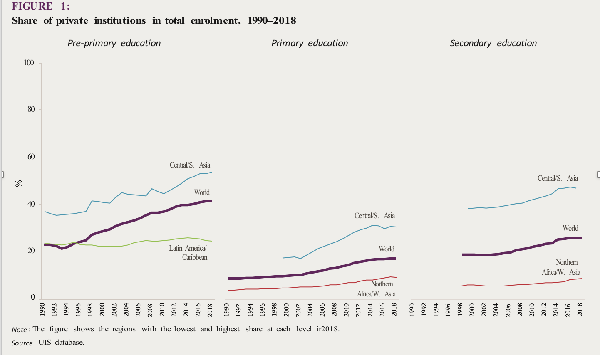

Figure 2 is explained as below…

“In tertiary education, data are patchier. Among countries with sufficient availability of data over the past 20 years, the average share of private institutions suggests no clear trend, with about one in four students being enrolled in private universities. However individual countries differ widely. The share of students in private universities is as high as 73% in Brazil and 80% in the Republic of Korea. It has increased in countries such as Finland and Mongolia but decreased in Colombia and Portugal (Figure 2)”.

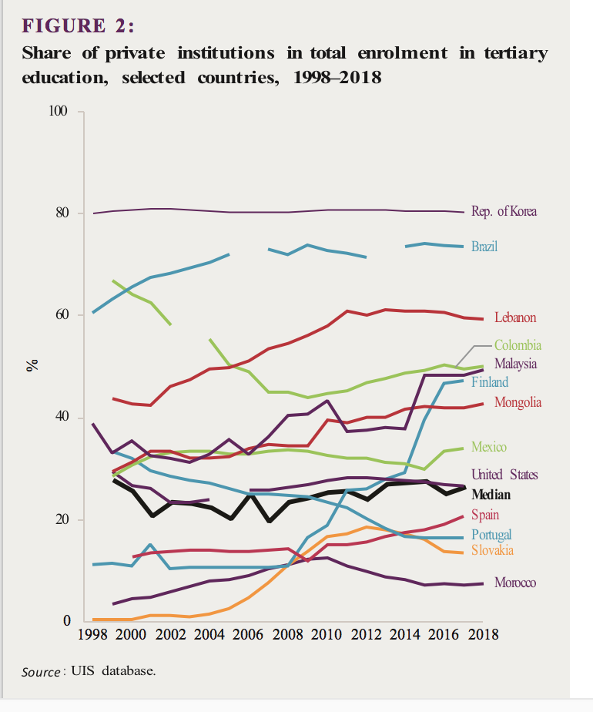

The share of private institutions in HE has to be cross related to the participation rate in higher education from all groups, and to levels of national wealth, to make much sense of the fluctuations. Interpreting shifts in enrolment rates (and number of institutions) is complex and linearities may be less likely than non linear compositional changes.
Korea has always had a lot of private higher education and it spends about half as much on higher education as it does on primary education; the UK has had very little private higher education since the 1950s. The political economy of higher education, and changing ideology for financing, have much influence over how HE systems are financed as they grow. No conclusion can be drawn from the fluctuations without a lot of collateral information which may indeed be the best message to project from this kind of data.

High participation in HE is often associated with a majority of female enrolment. Most high income countries have more girls than boys enrolled, often by substantial margins of 25% or more. The growth in participation in some countries may conceal growing inequality.

These two examples illustrate some of the difficulties of presenting data with complex underlying causalities. When data is curated by organisations with a commercial or political stake in outcomes the risks are clear. Independent sources are essential.

https://gemreportunesco.wordpress.com/2020/03/13/rethinking-non-state-engagement-in-education/
http://keithlewin.net/wp-content/uploads/2017/05/Keith-Lewin-Privatising-Educational-Services-for-the-Poor-University-of-Illinois-2017-Finalpdf.pdf
https://vimeo.com/53410853
Srivastava P Rethinking Non State engagement in education. World Education Blog 2020 https://gemreportunesco.wordpress.com/2020/03/13/rethinking-non-state-engagement-in-education/
https://eurodad.org/Entries/view/1547101/2019/11/13/The-escalating-costs-of-public-private-partnerships-in-the-UK-I
Zeitlyn, B, Lewin K M, Chimombo J, Meke, Elizabeth (2015) Inside Private Secondary Schools in Malawi: Access or Exclusion? International Journal of Education and Development (IJED) https://www.sciencedirect.com/science/article/pii/S0738059315000723
Chimombo J, Meke E, Zeitlyn B, Lewin K M (2014) Increasing access to secondary school education in Malawi: Does private schooling deliver on its promises? http://keithlewin.net/wp-content/uploads/2015/08/PERIMalawiWP-61_Increasing-Access-to-Secondary-School-Education-in-Malawi.pdf Research report at https://keithlewin.net/wp-content/uploads/2020/04/Private-Secondary-Education-in-Malawi-Report-2013-Full-PDF-Editing-Copy-.pdf
I) Peak Aid https://www.ukfiet.org/2019/peak-aid-and-time-for-something-different-sustainable-financing-for-education/ ii) Webinar on Tax, aid and privatisation (March2020): https://youtu.be/wlxAZLd8IY0
Podcast: Educational Financing. Freshed. http://www.freshedpodcast.com/keithlewin/
Lewin K M (2015) Educational Access, Equity and Development: Planning to Make Rights Realities. Fundamentals of Educational Planning Serial Number 97. International Institute for Educational Planning, UNESCO, Paris https://unesdoc.unesco.org/ark:/48223/pf0000235003
https://www.ukfiet.org/2018/education-outcomes-fund-eof-for-africa-and-the-middle-east-is-it-a-game-changer/.
See Annex 1 below.
The Limits to Growth of Non-Government Private Schooling in Sub Saharan Africa ( Summary) Authors: Keith M Lewin Date: June 2007 http://www.create-rpc.org/pdf_documents/PTA5.pdf

