The Sustainable Development Goals for Education;
Commonwealth Perspectives and Opportunities

Keith M Lewin

List of Contents

Introduction 2
Education in the Commonwealth 2
Demography and Economy 2
Enrolments 3
Higher Education 5
Teachers 6
Location 7
Curriculum issues 7
Financing 7
The Commonwealth Post 2015 Framework 8
Opportunities for the Commonwealth Member States to Take Back Control 13
A Programme for Action towards 2030 16
Annexes 20
Annex 1: Commonwealth Post 2015 Development Framework for Education 20
Annex 2 Targets and Indicators for SDG 4 24
Annex 3 MDGs and Dakar Targets 27
A.1 Millennium Development Goals for Education (2000) 27
A.2 Education for All Goals (2000) 27
References 29

Table 1. Key facts on Commonwealth countries 3
Table 2 Overage, enrolment, gender and GER at primary level 3
Table 3 Overage, enrolment, gender and GER and NER at secondary level 4
Table 4 NER, gross intake to secondary and completion rates at secondary 5
Table 5 Enrolment as a proportion of the total in TVET at secondary level 7
Table 6 Participation in tertiary education 5
Table 7 Primary teachers and qualifications 6
Table 8 Secondary teachers and qualifications 6
Table 9 Education finance in Commonwealth countries 8

The Sustainable Development Goals for Education;
Commonwealth Perspectives and Opportunities

Keith M Lewin

Introduction
The Commonwealth is an organisation well placed to play a key role in catalysing both sustainable educational development (SED) and education for sustainable development ESD. SED generates and sustains the conditions under which education systems can deliver rights to education and provide infrastructure, learning materials and sufficient teachers for high quality learning to available to all. This has to be achieved without a destructive burden on planetary ecology. ESD reflects engagement with the “question learning for what” and challenges educators to undertake the kind of curriculum and pedagogic reforms that are needed to determine how the 15,000 hours children spend in school needs to change if the next generation are to behave differently and revalue the future.

In 2012 the Commonwealth Minsters set up a Sub-Committee on post 2015 educational development. It produced a framework of Commonwealth Goals and Targets (CMGT) and illustrative indicators. This fed into and influenced what became the Sustainable Development Goal 4 of the UN Sustainable Development Goals in 2015. This paper reflects on this process and the challenges that now lie ahead. The Commonwealth Minsters have been meeting since 1959. SED and ESD may well be the biggest challenge that they have confronted. The 20th CCEM asked the question “Sustainability and Resilience: Can Education Deliver?” There is probably not much more than a decade to get a definitive answer.

First, the paper offers a descriptive analysis of key features of Commonwealth education systems to set the scene and provides discussion on economy, demography, enrolments, higher education, teachers, location, curriculum issues and financing. Second the Commonwealth Post 2015 framework for education is described. Third, the opportunities for the Commonwealth to take back control of the sustainable development agenda are explored. Fourth a possible programme for action is outlined to give food for thought.

Education in the Commonwealth

Demography and Economy

The Commonwealth is very diverse and Commonwealth Member States (CMS) include the very rich and the very poor. About 14% are Low Income Countries (LICs), 28% Low Middle Income Countries (LMICs), 32% Upper Middle Income Countries (UMICs) and 26% are High Income Countries (HICs). This can be compared with the global distribution of countries – 12% LICs, 29% LMICs,, 31% UMICs and 29% HICs. Surprisingly to some, the Commonwealth mirrors the global distribution of countries in terms of national income fairly closely. Regionally 34% of CMSs are in Africa, 14% in Asia, 24% in the Americas and the Caribbean, 6% in Europe and 22% in the Pacific. Table 1 presents some key facts on Commonwealth Member States (CMS).

Table 1. Key facts on Commonwealth countries

 |  | Populat-ion  Total | Population growth  Average % p.a. | GDP per capita  Average | GDP  PPP/cap  Average | Average % Below Poverty  Line | Average Under-5 mortality | Stunting
 |  | Million |  | $ | $ | % | % | %
LICs | Total | 165 | 2.72 | 639 | 1,705 | 56 | 68 | 38
LMICs | Total | 2,051 | 1.64 | 2,362 | 5,059 | 26 | 51 | 30
Upper UMICs | Total | 95 | 0.73 | 8,005 | 14,034 | 7 | 21 | 10
High-income | Total | 141 | 0.85 | 30,944 | 41,377 | 1 | 8 | 8
Note: This table divides the Commonwealth into four groups of countries: GDP per capita less than US$1,000, $1,000–4,000, $4,000–15,000 and above $15,000. The same categories are repeated in the tables below. Averages are unweighted.
Source: Own calculations based on data from UIS data (2017).

Nearly 2.5 billion people reside in Commonwealth countries. The richest countries have population growth below 1 per cent and are likely to have fewer children than adults in the population and declining enrolment in schools. The poorest countries have population growth over 2.5 per cent, with a doubling of the number of children every 25 years or so. They have many more children than working adults.

Average per capita incomes in LICs, LMICs, UMICs and HICs are about $640, $2,360, $8,000, and $30,900 respectively. Average GDP per capita within the country groups varies by more than 50 times, showing extreme differences in wealth and financial resources. More than half those in the poorest countries are below national poverty lines. Under-five mortality can be over 65 per cent, and up to 40 per cent of children are stunted. This is true only in a small number of the poorest Commonwealth countries. LMICs and HICs have very good social indicators.

Over 80% of all people in the Commonwealth (2.5 billion) are in LMICs. Most of the under 14 years old population in the Commonwealth are necessarily in LMICs. They total about 610 million, compared with 77 million in LICs. Overall about 10% are in LICs, 82% in LMICs, 4% in UMICs and 3% in HICs. India, Bangladesh and Pakistan are all LMICs and account for 65% of all young people in the Commonwealth. In Africa only 40% are in LICs and the rest in LMICs and UMICs. If the messages of sustainable development are to reach the next generation of Commonwealth children, the need is to focus on those in LICs and LMICs where the largest numbers are to be found.

Enrolments

Commonwealth countries have high enrolment rates at primary level, with average gross enrolment rates (GERs) well over 100 per cent (Table 2). A GER over 100 per cent means more children are enrolled than are of primary school age.

Table 2 Overage, enrolment, gender and GER at primary level
Country income |  | Primary GER | Female | Overage
 |  | % | % | %
LICs | Average | 117 | 50 | 29
LMICs | Average | 108 | 48 | 22
UMICs | Average | 104 | 49 | 4
High-income | Average | 101 | 49 | 0
Source: Own calculations based on data from UIS data (2017).

In LICs and LMICs between 20 and 30 per cent of primary school children are overage by two years or more. This means that, for example, they would be 14 years or more at the end f a six year primary cycle. Being over-age compromises their learning and disadvantages them in high stakes selection examinations (CREATE 2011). Children are over-age either because of late entry or because of grade repetition. Although most countries have automatic promotion policies, in practice these may not be consistently applied, especially outside urban areas and in schools serving populations with low socio-economic status. UMICs and HICs do not have overage children in any quantity. Sustainable educational development depends on managing entry to school and learning so that no children are over-age in class.

Across all the Commonwealth countries, gender parity in enrolment has largely been achieved at primary level. The percentage of females averages between 48 and 50 per cent, with more girls enrolled in richer countries. Only one country—Pakistan at 45 per cent—has a gender ratio below 47 per cent according to UNESCO Institute for Statistics (UIS) data (UIS, 2017). This is an encouraging story and shows how historic disadvantages have been overcome in enrolment imbalances. In every country in Africa that takes the Southern African Consortium for Measuring Educational Quality assessments, girls are on average now younger than boys, suggesting they enter earlier and progress faster.

Enrolments at secondary level are yet to reach universal levels in the poorest Commonwealth countries (Table 3). In LICs, the GER is only 36 per cent, and in LMICs it is 69 per cent. GERs in UMICs exceed 93 per cent and those in HICs are over 100 per cent.

Table 3 Overage, enrolment, gender and GER and NER at secondary level
Country income | Overage | Female | Secondary GER | Lower secondary NER
 | % | % | % | %
LICs | 45 | 48 | 36 | 69
LMICs | 29 | 49 | 69 | 84
UMICs | 13 | 50 | 93 | 92
High-income | 1 | 49 | 106 | 97
Note: NER = net enrolment rate.
Source: Own calculations based on data from UIS data (2017).

Considerably more children appear overage in secondary than in primary, with between 45 and 29 per cent overage in LICs and LMICs. The problem is non-existent in HIC. Overall gross enrolment rates (GERs) average 36 per cent for the whole secondary cycle in LICs and 69 per cent for LMICs. Net enrolment rate for lower secondary average 69 per cent and 84 percent in low- and LMICs, indicating that many students fail to make the transition from lower to upper secondary.

Gender issues persist but now take many nuanced forms. Generally, while the poorest girls face many barriers to accessing education, once in school their retention is better than that of their poor male counterparts (UNESCO, 2016a). High and middle income girls are more likely to be enrolled than poor girls and high- and middle-income boys. Residence in rural areas and informal settlements and cultural preferences are often identified as the most common barriers to girls’ education. In parts of Nigeria, less than 30 per cent of the poorest girls have access to primary school (UNESCO, 2015)

Upper secondary participation averages about 37 per cent in terms of the NER in LICs, and 53 per cent in LMICs (Table 4). The gross intake rate to secondary in LICs is only a third (32 per cent) of the rate in UMICs (88 per cent), indicating the size of the enrolment challenge at this level. Poor countries in the Commonwealth have lower and upper secondary completion rates of only 26 per cent and 14 per cent, and LMICs of only 52 per cent and 30 per cent, respectively.

Table 4 NER, gross intake to secondary and completion rates at secondary
Country income | Upper secondary NER | Lower secondary gross intake rate | Lower secondary completion rate | Upper secondary completion rate
 | % | % | % | %
LICs | 37 | 32 | 26 | 14
Lower-middle income | 53 | 71 | 52 | 30
UMICs | 72 | 88 | 84 | 62
High-income | 90 | 101 | 99 | 84
Source: Own calculations based on data from UIS data (2017).

Many children remain out of school in Commonwealth LICs. Out-of-school children are disproportionately poor, from indigenous, low-caste or tribal backgrounds. The United Nations, Educational, Scientific and Cultural Organization (UNESCO) Institute of Statistics (UIS) data indicate that about 13 million Commonwealth children of primary education age, and 22 million of secondary age, are out of school. If this is true, this represents about 10 per cent of all Commonwealth children below the age of 15 years. Most are in South Asia. If those in school and not learning are included, the numbers will be much larger. Whatever the numbers are, they represent a population of citizens whose right to education needs to be realised. This means there is a need for different approaches to delivering services, especially to small and multi-graded schools necessary to reaching out to unserved populations (Little, 2004).

Higher Education

Investment in expanded access to tertiary-level programmes is happening across the Commonwealth. About 45 million students are registered in tertiary institutions in the bloc. Participation rates are growing faster than at other levels (Table 6). LICs have a tertiary GER of about 6 per cent and LMICs a tertiary GER of 15 per cent. About a third of young people in UMICs and nearly 60 per cent in HICs now access tertiary programmes. In all Commonwealth countries except the poorest, more girls than boys are now enrolled at tertiary level.

Table 5 Participation in tertiary education
Country income | Total | Female | GER | Male GER | Female GER
 | ‘000 | % | % | % | %
LICs | 580.4 | 41.4 | 5.7 | 6.7 | 4.7
Lower-middle income | 37,194.5 | 58.3 | 14.9 | 15.1 | 22.0
UMICs | 2,020.7 | 59.2 | 33.0 | 27.7 | 38.5
High-income | 4,397.7 | 58.4 | 57.9 | 46.6 | 69.6
Source: Own calculations based on data from UIS data (2017).

Challenges to tertiary education for sustainable development include those related to programme quality, funding, staff development and regulation, comparability of degrees and employability of graduates (Commonwealth Secretariat, 2017a).

Finding the right balance between tertiary education and other sub-sectors will be crucial. In some parts of Africa, 60 per cent of the working-age population are unemployed, and many young people queue in labour markets waiting for modern sector jobs. Some reports indicate that only half of those Africans who graduate from Universities – about 10 million per year - will secure graduate-level employment. In contrast, graduate tracking at the Singapore Institute of Technical Education shows that over 80 per cent of all graduates are able to secure employment within 12 months of graduation. This is attributed to effective alignment of graduate skills with labour market needs (Commonwealth Secretariat, 2015a).

Teachers

Most teachers in CMSs are qualified, but between 5 and 30 per cent remain unqualified, with higher rates in the poorest countries. PTRs in primary vary from around 50:1 to less than 15:1. At secondary, the range is from nearly 30:1 to only 10:1. Qualified teacher ratios are greater and range from 60:1 to 14:1 in primary and 40:1 to 10:1 in secondary (Table 7 and Table 8).

Table 6 Primary teachers and qualifications
Country income | No. of teachers | Qualified | PTR | Qualified teacher ratio
 | ‘000 | %
LICs | 668 | 77 | 48 | 61
Lower-middle income | 6,037 | 72 | 31 | 44
UMICs | 524 | 78 | 20 | 35
High-income | 309 | 95 | 14 | 14
Source: Own calculations based on data from UIS data (2017).

Table 7 Secondary teachers and qualifications
Country income | No. of teachers | Qualified | PTR | Qualified teacher ratio
 | ‘000 | %
LICs | 186 | 77 | 28 | 40
Lower-middle income | 5,512 | 80 | 20 | 24
UMICs | 278 | 70 | 14 | 32
High-income | 463 | 98 | 10 | 10
Source: Own calculations based on data from UIS data (2017).

These differences in teacher provision have implications for costs and for resilience. High PTRs mean that cover for absences will be difficult, crisis management cannot be individualised and collective responsibility for learning will be difficult to generate.

Location
Expanded access to school should respect concerns for sustainable development. Location has large-scale implications for energy use and pollution and thus for sustainable development. Children are increasingly transported to and from school, especially in urban areas in LICs and LMICs. In some countries the largest source of urban traffic growth has been the ‘school run’. This gridlocks traffic, with all its opportunity costs, and releases huge amounts of particulates into the atmosphere, with consequences related to respiratory diseases. School provision is generally not planned with its environmental burden in mind. Commitment to sustainable development means that the Commonwealth should consider how this could be encouraged through school mapping, energy audits of infrastructure and learning activity.

Curriculum issues

Curriculum reform is important for several reasons. First, it can help translate school knowledge into employable skills that promote economic growth. If these are acquired with an awareness of sustainable use of resources and disposal of waste, this can be reflected in more environmentally friendly production. Second, effective pre-career education and training can help students identify occupations and livelihoods that are attractive and available. Third, a balanced national curriculum will include knowledge and skill directly related to sustainable development as well as that that enhances well being and cultural identities. UNESCO has attempted to develop a global framework of learning goals for sustainable development (UNESCO 2017) this simply uses the SDGs as the basis for a mechanical translation of the Goals into behavioural objectives. The SDGs were not devised with this use in mind. It would be surmising if they mapped onto a pedagogically enlightened and epistemologically coherent curriculum of ESD. CMSs could take the opportunity to do better.

We can note that in most Commonwealth countries, only a minority of students take TVET programmes rather than follow a general curriculum (Table 5) reflecting patterns of effective demand. Participation in TVET LICs and LMICs is often not much more than 10 per cent of the age group. These estimates are uncertain, since definitions of TVET vary and classification is carried out in different ways across countries. More TVET is available post-school at non-degree further education level. Formal TVET often attracts more boys than girls, and some programmes are strongly gendered. TVET has been more driven by employment opportunities than concerns for sustainable development and ecological conservation.

Table 8 Enrolment as a proportion of the total in TVET at secondary level
Country income | Total | Male | Female
 | % | % | %
LICs | 11.5 | 13.1 | 10.0
Lower-middle income | 4.7 | 5.8 | 3.6
UMICs | 6.5 | 7.9 | 5.1
High-income | 14.6 | 16.0 | 13.1
Source: Own calculations based on data from UIS data (2017).

Financing
Educational financing is taking new forms across the Commonwealth as different challenges become clear. The appetite for aid to education is softening; new donors (sovereign wealth funds, philanthropists, corporate interests) have new priorities and self-interests; and aid dependence stubbornly persists in some of the poorest countries bring into question the efficacy of some types of aid (Burnett 2012, Easterly 2013, UNESCO 2016, Lewin 2017). At the same time more and more CMSs are becoming fiscal states able to finance public goods from domestic revenue.

The basic dilemma of public education financing of recurrent costs of education systems can be explained briefly. LICs and LMICs in the Commonwealth collect on average 17 per cent of GDP in domestic revenue, from which all public expenditure funding comes. At the same time, they allocate on average 17 per cent of total public expenditure to education (16 per cent in LICs and LMICs and 15 per cent in HICS. The result is that about 4 per cent of GDP in Commonwealth LICs and 5 per cent of GDP in HICs is spent on education (Table 9). Between a quarter and a half of the 4% of GDP in LICs and LMICs in some CMSs is supported from external financing.

Table 9 Education finance in Commonwealth countries
Country income | Expenditure as % of GDP | Expenditure as % of government budget
LICs | 4.0 | 16.2
LMICs | 4.2 | 16.7
UMICs countries | 5.1 | 17.1
High-income countries | 5.2 | 14.9
Source: Own calculations based on data from UIS data (2017).

Financial modelling undertaken by the author for the Global Partnership for Education shows that at least 6 per cent of GDP would need to be allocated to education in LICs and LMICs to achieve the goals set by national governments and under the SDGs (Lewin, 2017). This requires a substantial increase in domestic revenue, and an increase in the proportion of this allocated to the education budget. In order to allocate 6 per cent of GDP to education, domestic revenue would need to be about 24 per cent of GDP and educational expenditure would have to be 25 per cent of total government spending (25% of 24% = 6). This is well above current levels. Achieving such large increases in domestic revenue will not be easy but is feasible over time. It requires substantial fiscal reform that reduces avoidance and evasion, fraud and deliberate transfer pricing to minimise tax. It would also require governments to increase their own spending and demonstrate the political will that signifies ownership of educational financing.

In addition gains from educational reforms that promote greater efficiency and effectiveness could be substantial. This may be the most cost-efficient way of generating more resources. There are many possibilities and there is much experience across the Commonwealth that can be shared. More aid to education is unlikely to be a sustainable solution. Critically aid should never be used to finance recurrent expenditure (e.g. teachers salaries) which is the main element in all education budgets. Higher levels of external support, especially if they are needed indefinitely, create aid dependence and distort domestic decision-making. Aid dependence makes sustainable development financed from domestic revenue more elusive. Innovative finance initiatives are widely discussed. To date none of these is capable of generating the volume of money needed to finance a significant amount of education budgets in CMSs. All the mechanisms have costs, and some generate new debt that has to be paid off in the future, and many benefit commercial intermediaries in the global finance sector.

The Commonwealth Post 2015 Framework

In 2012 the Commonwealth Ministers established a Ministerial Working Group on the Post 2015 Development Framework which I had the privilege of advising. This met several times and produced a position paper that contained the “Commonwealth Recommendations for the Post-2015 Development Framework for Education”. These are reproduced in Annex 1. The recommendations were widely circulated around multilateral partner organisations (e.g. UNESCO, UNICEF, UNDP) and bi-lateral donors for education (e.g. DFID, CIDA and AusAid).

There were various dissatisfactions across the Commonwealth with the international architecture that emerged from the World Education Forum in Dakar in 2000 and the Millennium Development Goals (MDGs) adopted by the U.N. in 2000. These were captured in a plenary address to the 18th CCEM in Mauritius (Lewin 2012). In sum it was felt that:

- Patterns of investment by development partners had become heavily skewed towards increasing access to basic education in general and primary education in particular. This reflected the priorities of some Commonwealth member states (CMS) but not many others. It had considerable influence on development agencies and those who were swayed by their preferences. No matter that post conflict and fragile states might need to rebuild their cadre of middle and high level officers and employees to manage reconstruction basic education was often privileged for concessionary investment.

- The approach adopted by the U.N. failed to differentiate between countries in terms of starting points and was largely blind to aspirations that fell outside the “Washington consensus” of what needed to be done. The goals and targets de facto were intended to apply most to LICs and LMICs in need of development assistance. De jure they applied to all U.N. member states though the OECD mostly assumed that they had already met any educational target of value.

- Though improved quality was explicitly included in the Dakar Targets (DTs), as it had been in the earlier “World Declaration on Education for All and Framework for Action to Meet Basic Learning Needs” endorsed by the U.N. in 1990 the reality had been to privilege enhanced access over improved quality and learning outcomes. Rapid expansion in enrolments had predictably brought with it lower levels of achievement as expanded cohorts struggled with curricula designed for more able pupils and as investments in training teachers failed to keep pace with demand.

- Similarly though equity was stressed in the EFA rhetoric very little appeared to be enacted that would enhance equity in terms of participation and performance correlated with household income and location. By 2015 the chances of those from the lowest decile of household income of completing secondary school were often one fifth and sometimes less than one tenth of those in the richest quintile. There was also evidence that expanded enrolment in post basic education had mainly benefitted those in the middle of the income distribution not the poorest.

- By contrast it was clear that considerable progress had been made in ensuring equal number of boys and girls participated in school. Most Commonwealth countries achieved this in primary education by 2010 and at secondary education by 2015. Almost all countries with substantial enrolments in higher education saw a preponderance of girls enrol in degree courses to the extent that they out enrolled boys by 20% or more. At the same time gender based interventions proliferated but were disproportionately directed towards marginalised girls rather than boys. This despite it becoming increasingly well known in some regions of the Commonwealth boys were consistently under achieving.

- Investment in educational infrastructure lagged enrolment expansion as did provision of learning materials including text books. Paperless schools remained common in the poorest CMSs not because of the internet and information technology but because there really was no paper and nothing to buy it with.

- Many observers felt that part of the problem with the Dakar Targets (DTs) and the MDGs was that there was far too much distance between the “target setters and the target getters”. Disembodied officials drafting goals and targets endorsed by politicians most of whom were not in office five years later presented a tough call for implementation with passion. Surprised target getters felt themselves signed up to aspirations that were sometimes impossible to realise on time with the resources available and other times were pleasantly reassured that particular targets had already been achieved a long time before so little would need to be done.

- Rights based approaches were beginning to be challenged and not only by the long march of neo-liberalism. Rights cannot be realised without the development of fiscal states that can afford to provide public goods like education and health from domestic revenue. The alternative is aid dependence which as remained all too common amongst a cluster of about 30 Low Income Countries some of which are CMSs. These countries have consistently received more than 25%of their public budget in external assistance. Depending on foreigners to deliver rights to anything including education was always going to be sub-optimal and almost certainly not sustainable.

- Educational financing is at the core of educational development especially where resources are scarce, trade-offs in public investment have to be made between sub-sectors, and development assistance if offered from within and outside the Commonwealth. The EFA process succeeded in mobilising more than $300 billion in Official Development Assistance (ODA) since 1990 and CMSs were major beneficiaries. In some countries development happened and created fiscal states that can finance the row education systems. Others lagged behind and are still dependent on external financing. India now does not seek grant aid and proudly announced recently that it gave three times as much aid as it received. By contrast aid still provides more than a third of government income in CMS LICs. New approaches were needed that could support fiscal reform and generate sufficient economic growth to sole the problem of financing mass education systems without dependence on aid.

- Lastly the DTs and MDGs were both lists not recipes. Putting them all into a tin and baking them together held no guarantee that a perfectly formed cake would emerge. Though laudable in themselves each aspiration interacted with others, trade offs were not recognised, contradictions were and some ingredients lacked definition. Most worryingly the Goals and Targets were ossified by the bureaucrats pen with no intention to revisit the G and Ts before 2015. Between 2000 and 2015 events have intruded including 9/11, the Iraq, Afghanistan and Syrian wars along with many other serious conflicts, energy independence from the Gulf in North America, an increase in China’s GDP by ten times and GDP per capita by nine times, global inequality leading to 25 people having as much wealth as the poorest 50% in the world, and general acceptance that global warming is a present and persistent threat to life on earth that needs a new approach to development.

The Commonwealth Ministers working group’s deliberation resulted in a new formulation of goals and that responded to concerns to a greater or lesser extent – the Commonwealth Goals and Targets for 2030 (CMGT). This Framework was adopted and disseminated into the on-going U.N led SDG consultations with a particular focus on UNESCOs since it had the role of the coordination agency foe education and development. The framework developed was presented at various regional fora that channelled country, NGO and agency proposals into the series of meetings that led from regional consultations to the Oman Conference on the SDGs and to the endorsement of SDG 4 at the World Education Forum in Incheon in 2015. The final version of the SDG 4 along with its short list of 43 indicators is included in Annex 2.

The Commonwealth Ministers discussions around the Post 2015 Goals recognised the three possibilities identified by the Economic Commission for Africa. These were

- Retaining the current MDGs and extending the timeline;
- Restructuring the MDGs, to eliminate overlaps and include issues originally omitted (‘MDG-plus’);
- Replacing the MDGs completely with an alternative framework which would focus on:transforming the structure of the economies of developing countries, structural transformation and greater reliance on domestic resources and revenue (UNECA, 2012: 131).

In discussion three additional possibilities for the Post 2015 Education Goals and Targets (G and T):

- G and T ‘lite’: a two-tier framework, with high level goals linked to regions/groups and context, and lower level goals defined at national or regional level.
- G and T ‘heavy’: a standardised framework with detailed global specifications linked to performance and funding.
- G and T ‘Rest In Peace’: termination of a global framework to be replaced by separate national, bilateral and multilateral projects. Each of these options had advantages and disadvantages (Lewin 2012).

Retaining the existing goals would mean that the existing planning, implementation and monitoring structures could be retained, political momentum sustained, and countries which commenced in 2000 from a low starting point would have time to achieve the goals. This option would not be responsive to the changed global political and economic environment, and would shift the discourse from a global agenda to only those countries who will not have met the Education for All, EFA 2000 goals by 2015.

Restructuring the goals would respond to the changed context, and allow re-prioritisation of areas of action. This would provide structure and process for new priorities such as inclusive economic growth, skills for employment, climate change, and new approaches to quality and equity.

Replacing the goals would require constructing a new approach to development which is not based on aid but on a more comprehensive and cohesive international agenda. The aim of structural transformation would focus on development ‘enablers’ rather than development ‘objectives’ (UNECA, 2012). While aiming to transcend geostrategic blockages to development, this approach risked losing what remains of the international consensus around the elimination of poverty. By re-designing the system in the light of the learning from the past it had the potential to be more focussed and effective.

The proposed two-tier goals (G and T lite) introduced a layer of complexity and differentiation in priorities. This structure of Goals and Sub-goals was included in the CMGT but not SDG 4. It was intended to allow more realistic national or regional level goals responsive to different initial conditions, national priorities, and available resources to be set under the umbrella of a global framework. Some differentiation based on contextual realities is necessary to successful attainment (Crossley and Watson, 2003). Differentiation might take the form of different attainment levels, or of different timescales for achieving targets, or of different prioritisation of goals. Differentiated goals make specific targets more achievable, measurable and more accountable. Country-specific targets would allow greater specificity in indicators, and allow for secure national ownership within a global framework.

Neither the Commonwealth nor the U.N. processes turned out to have sufficient courage or a consensus of imagination to seriously discuss the radical options of inventing new development paradigms. Nor did it take long to reject the option of simply abandoning a global architecture in favour of a country led, bottom up, collection of differing approaches to educational development reflecting a myriad of differing priorities and preferences.

In 2015 SDG 4 was endorsed at the WEF in Incheon. The result was a set of SDGs that closely resembled the goals and targets of Education for All in 2000, or even EFA in 1990. Several of the existing goals were retained or rolled over from the DTs and MDGs. SDGs 4.1, 4.2, 4.3, 4.4, 4.5, and 4.6 have clear analogues in the EFA architecture. They emerged early in the Commonwealth deliberations too which added weight to their later inclusion in the SDG4. The Commonwealth framework also anticipated the inclusion of preschool participation in its sub-ordinate goals, adequate teaching staff to support higher level of participation, and included a concern for education related directly to livelihoods and employment and TVET.

Nuances can be important and are reflected in some aspects of how the SDGs are now evolving and their strengths and weaknesses. Several points stand out which are discussed below.

The CMGTs endorsed the commitment to a full cycle of 9 years of free continuous basic education leading to learning achievement in line with national norms (CMGT1). SDG4 is now widely interpreted as requiring States to provide 12 years of formal education to all citizens. Even in middle income CMSs the case for this remains to be made securely since it implies retaining children in school when well over the legal minimum age for work. More particularly ways are needed to finance this level of provision from limited tax bases. IThe SDG has created an apparent anomaly – 54% of children out of school according to the GEMR are 16 years old or older, and 75% at 14 years or older. These are global aspirations transplanted to countries where the trade offs necessary to achieve the goals look very different to those in rich CMCs. Rich country levels of provision need rich country demography and revenue raising commitments.

Learning outcomes were also stressed in the CMGT as being inseparable from access and national aspirations. The SDGs appear to be privileging international achievement testing over national curricula priorities. This has some merit but also largely ignores the need to develop national curricula that are not all the same, especially at higher levels.

In addition the CMGT deliberately drew attention to the importance of age appropriate progression rates in low income countries where over 30% of children can be two years over age or more with measurable consequences for drop out and levels of achievement. Full enrolment means absence of age grade slippage. This is now being used by UIS as a indicator for SDG 4.

SDG4 has blended commitment to universal access at primary and secondary level into one goal. The CMGT deliberately kept basic education up to grade 9 separate from post basic education. This was partly to mediate the pressure to commit to unrealisable goals in LICs of universal levels of participation for children up to their late teens, and partly to encourage countries to set their own targets rather than adopt universal ones. This is especially important for high cost tertiary education. Unlike SDG4 which has three Targets for TVET (4.3/4/5) TVET is encompassed within CMGT 2 which emphasises the importance of all post basic education having relevance to employment livelihoods and well being (SG (iii)).

The SDGs do recognise the importance of equity following on from the CMGT Goal 3. Equity was felt to be so important it warranted its own Goal statement in the CMGT. As access issues are resolved the focus has shifted to persistent inequality which in some cases has been worsening. The SDGs emphasis inequalities of access more than inequalities of outcome, though it is the latter that determine life futures.

The CMGTs included commitment to ECD and preschool as a Subgoal (SG (i)). The SDGs give it prominence as a headline goal, as did the Dakar Targets in 2000. In contrast SDG 4.7 on global citizenship was not anticipated by the CMGT which was more concerned with citizenship especially of the growing number of migrants. This was judged more important that a loosely defined concept of global citizenship that assumed cross cultural consensus on values and political economy that remains elusive.

The CMGT also anticipated the importance of an adequate supply of teachers and this appeared as SDG 4.a. The CMGT did not anticipate the SDG 4b which seeks to increase the flow of scholarships to support study in high income countries. This ambition appeared with no development rationale in the SDGs and remains problematic. If it were enacted it could have an adverse impact on the domestic higher education systems and would reduce investment in building capacity at home. It would also have a substantial impact on carbon emissions and global warming.

SDG 4 is becoming more like the unified global framework anticipated by the G and T heavy scenario. There are signs of increased standardisation, conditionality associated with concessionary finance, outcomes based aid, and global convergence in expectations. This risks a lack of situation specific relevance, limited resilience and conflict over divergent in aspirations (Lewin, 2012). The MDGs and EFA were generally interpreted as applying to LICS or LMICs. The new development framework was constructed such that goals and targets apply to all countries, with an unrealised nod to the idea that countries would develop their own framework of goals and targets led by global lists and common accounting systems. This was not the new dawn or endogenous and sustainable development some had anticipated would evolve from the MDGs.

Opportunities for the Commonwealth Member States to Take Back Control

Many of the original criticisms of the MDGs and DTs are re-emerging in relation to SDG4. The diversity of the Commonwealth indicates how ambitious the SDGs are in attempting to generate a single list of goals equally relevant to all countries. It may be time for the Commonwealth to revisit how helpful SDG4 is and develop its own more nuanced goals that reflect the realities and priorities of CMS. The list of current concerns about SDG4 echoes the criticisms that led to the CMGT. These issues could form the basis of a new agenda for Commonwealth Ministers initiative that seeks to take back control of the global development framework in ways that reflects Commonwealth conditions and national priorities. Key issues are discussed below.

First, the preference of development agencies towards investments in basic education remains albeit with an ambitious inclusion of the whole of the secondary cycle. This is driven by a rights based approach more than a coherent theory of development. The problem is that this approach suits some developmental conditions but not others. It is becoming clearer and clearer that sustainable development in most CMS does not require more aid but more investment in fiscal reforms, greater efficiency and effectiveness, and better management of economic growth. The most successful CMSs can provide examples of the pathways that need to be followed.

Second, increasingly the emphasis on measuring learning of the SDGs is being translated into internationally standardised testing in the early grades which assumes global curricula convergence and does little to recognise different starting points and preferences for outcomes not captured by the tests. Improved quality is not being captured or promoted by such testing and more measurement delinked from classroom level formative assessment is simply replicating findings of under achievement in LICs and LMICs that are well known. High performing SMSs can illustrate how bespoke assessment systems can minimise destructive examination backwash on learning and teaching and how formative assessment linked to pedagogic intervention can improve the management of learning.

Third, conspicuously there has been no widespread attempt to address questions of equity related to household income or location and there is some evidence that exclusion related to poverty may actually have increased in some CMSs despite growth in GDP. Gender equity has been addressed and across the CMSs participation rates are close to parity. It is increasingly common to find girls out enrolling boys. The most equitable CMSs can demonstrate how reducing gaps in participation and achievement can contribute to social justice and economic growth.

Fourth, it has proved very difficult to close the digital divide of access and capability between the rich and poor CMSs not least because the leading edge moves so fast. CMSs, especially small island states, can collaborate to show how these gaps can be managed at affordable costs. More generally managing and regulating the internet and social media and safeguarding young people is a Commonwealth wide problem. If the Minotaur and the Hydra are to be reigned in the architects and owners of information technologies have to be reminded by governments that with power comes moral responsibility. An approach across CMSs will have more influence than ad hoc legislation.

Fifth, the SDGs, like the MDGs and DTs, appear frozen in aspic. There is no on going Commonwealth dialogue that seeks to treat SDG4 as a dynamic framework that changes over time to reflect the importance of “events, dear boy, events. ” Neither have the SDGs been domesticated to reflect different contexts, ambitions and realistic possibilities. One of the key texts on the DGs wrestles repeatedly with tensions between a globalized approach to development, and an enduring attachment to the nation as the indivisible unit of development with many special and unique characteristics justifying special consideration. In an impressive linguistic judo trick the tension is resolved. “The SDGs and targets are integrated and indivisible, global in nature and universally applicable, taking into account different national realities, capacities and levels of development and respecting national policies and priorities. Targets are defined as aspirational and global, with each government setting its own national targets guided by the global level of ambition but taking into account national circumstances”. Examples of what this looks like in practice, especially for education systems, are strangely absent. The flavour of the SDGs, and their format, which volunteers few opportunities to modify, adapt or otherwise locate the goals and targets in different country circumstances, can easily be seen as symbolic of a “one size fits all” message emanating from the centre of a Washington consensus. The CMSs should grasp the challenge of national level Sustainable Development Goals for education, and insist that they evolve over time to reflect changing priorities and achievements. .

Sixth, the distance between target setters and target getters does not appear to have diminished. As the implementation of the SDG 4 has unfolded the delegation of assessing progress towards goals and targets has led to a dislocation. Political systems have been displaced by bureaucratic and highly technical indicator systems that nevertheless create pressure on CMSs to conform to global norms. This reifies the SDGs and invests nearly all its time in considering how to measure complex outcomes and very little time considering whether the outcomes have developmental causal significance. It is not clear what decisions by whom will make use of the big data sets being collected. Curiously the UNESCO Institute of Statistics has published a “Cheat Sheet for SDG4 Indicators” using the language of high stakes assessment and convergent global goals to implying somehow that they constitute a Mantra to be remembered and repeated on request (UNESCO 2019). CMSs with a clear idea of their national development strategies may wish to develop there own “cheat sheet” of what is important lined to a coherent theory of development that can shape investment decisions. This at least would mean the target setter and target getters spoke the same language.

Seventh, despite much comment emphasising that the MDGs and DTs were lists rather than a coherent basis for a strategy the SDGs repeated the same list format and omitted to engage with any theory of development that was explicit rather than tacit. This was an important omission especially for SDG 4. Thus the formulation of SDG 4 gives no indication and provides no environmentally sustainable targets or indicators for educational development despite the fact it is one of the largest sources of employment, non renewable energy use, polluting commuting, and one of the few places that can provide disinterested insight into the challenges of planetary husbandry to change attitudes and understand sustainability amongst the next generation. The CMSs could seek to develop planet friendly environmental protocols for educational development.

Eighth, though SDG 4.7 is concerned with global citizenship it just scratches the surface of the need to transform learning goals and plan education systems to minimise the burden on future generations. It is conspicuously not concerned with national citizenship which many think is a precondition for global citizenship. Within the CMSs there are millions of people whose citizenship is compromised and ambiguous. This includes internal and cross border migrants, excluded social groups, those with disability, and those without adequate documentation. The CMGTs noted migration as a cross cutting theme and stressed the importance of more inclusive approaches to citizenship, especially of children. The issues of citizenship in CMS are central to sustainable development.

Ninth, many in the low income CMS will have noted that the “learning crisis” flagged by the World Bank in 2018 is actually more of a financing crisis than a sudden discovery that children are not learning at OECD levels in CMS LICs and LMICs 9 (World Bank 2018, Lewin 2018). Many more children are in school and much more learning is taking place in CMSs than in 2000 or 1990. This is a very good news story. So also is the fact that many CMS are becoming fiscal states. The appetite for more aid to education appears to have been softening partly for these reasons. In 1990 Africa received twice as much in aid as it generated in domestic revenue. By 2015 the opposite was true. This rewrites the map of external assistance to education into the future. If the purpose of aid is to accelerate development and this works as a strategy then the number of recipients should fall as countries develop and become fiscal states. Some CMSs have led the way in showing that this can happen by becoming less and less dependent on aid. This is one area where Ministers of Education along with Minsters of Finance can demonstrate how to achieve sustainable educational development without more aid and more debt.

A Programme for Action towards 2030

A programme for action for CMSs can be built from the issues identified above. Specific solutions are needed at national level that capture the essence of both sustainable educational development (SED) and education for sustainable development (ESD). SED is concerned with the conditions that enable states to realise rights to education without post-colonial dependence external or acquiring unsustainable debt. It is concerned with educational infrastructure and the maintenance and development of systems for learning and their financing from domestic revenues. In contrast ESD is a response to the urgent need to transform educational curricula and learning outcomes to lead not lag changes in environmental stress points, demographic transitions, employment and threats to social wellbeing.

The Issues Paper for CCEM 20 was focused on Sustainability and Resilience: Can Education Deliver? In the medium term, both resilience and sustainable development mean that education systems must be financed from domestic revenues. This includes both income from taxation on individuals and corporate entities, and investment from the private sector and contributions from philanthropists. SED depends on fiscal reform that enables core of public goods like education to be financed from domestic revenue. This, along with enhanced levels of efficiency and effectiveness is the reason why high performing participation CMSs can support mass participation in quality education systems. This is the only method of achieving SED. Fiscal reforms are at the heart of the next generation of educational financing and can share the mechanisms that have most potential to contribute to the transition to fiscal states of those CMS that are still aid dependent.

Aid can be used to accelerate development. It is time to cease directing concessional finance to “filling gaps” in favour of investments that increase efficiency and effectiveness without undermining quality. This is perfectly feasible. The most efficient and effective education systems in the CMSs deliver universal access though to grade 9 and some to grade 12 at levels of financial commitment that are not very dissimilar to those where less than half of children complete secondary school. Efficient systems have cost per student at secondary no more than 50% greater than at primary. Inefficient systems have a ratio of cost of more than four to one. Similarly higher education costs per student in high income countries CMSs are generally only twice those of primary school places. In low income CMSs costs are more than 15 times greater ( Lewin 2015).

Fiscal reform is a high priority in countries where revenue collection is very low. To deliver quality education around 6% of GDP is needed and as much as 20% of government budgets. To do this implies that revenue collection that finances government has to be 30% of GDP (20% of 30% is 6%). Many LICs and LMICs average half this amount. This is not because they are poor so much as because they do not collect revenue and avoidance and evasion are commonplace. In poor countries many of the richest citizens pay little or no tax, nor do extractive industries or foreign domiciled multinationals. There is no sustainable educational development without fair and inclusive fiscal reforms that replace the politics of underfunding education and aid with the politics of a social contract between tax paying citizens and governments charged with providing public goods.

The next generation of aid and South-South cooperation has the opportunity to share insights and strategies on how to become fiscal states that manage SED into the future. This will not emerge from the SDG architecture without energetic engagement of CMSs in setting their own educational goals and targets with a firm commitment to both SED and ESD.

Education for Sustainable Development needs consensus on meanings attached to sustainability. The most commonly used definition for sustainable development is in the 1987 Brundtland Report. This argues that sustainable development meets the needs of the present without compromising the ability of future generations to meet their own needs. This valuing of the future over the present is essential to environmental protection and the ability of humanity to manage its planetary burden so that it does not irreversibly deplete geological, agricultural, maritime and atmospheric resources. This requires fundamental shifts in patterns of consumption, and a new economics of production, pollution and recycling. It needs an understanding that sustainable solutions require global consensus and cooperation.

The UN Decade of Education for Sustainable Development (DESD) ran from 2005 to 2014. DESD provided a global agenda that attempted to reframe education to meet the changing needs of a world in multiple crises and three pillars. These were economic, ecological and social. The ESD discourse argued for learning to emphasise the need for continuous engagement in sustainability in formal, non-formal and informal settings, and for participation and self-determination for sustainable development. The only problem was that ESD remained largely a niche preoccupation of educators based in HICs and little of its advocacy founds its way into curricula, especially those leading to high stakes selection examinations in LICs and LMICs.

Education for sustainable development is more than anything else a curriculum challenge and
requires curriculum development to ensure environmentally informed citizenry, encourage changes in consumption preferences, promote social cohesion and manage learning effectively. Curriculum reform especially at secondary level has been widely neglected and more frequently driven by the exigencies of high stakes assessment than by needs to allow all citizens to understand the vulnerabilities of the planet and the risk to well being from air pollution, water contamination, solid waste disposal and greenhouse gases. Curricula must lead learning assessments not follow from the demands of high stakes testing. Effective formative assessment that leads to better management of learning will have more impact on achievement than over investment in international assessments. If there is a learning crisis the solution lies in the curriculum. A resilient curriculum is one that is managed so that learning is cumulative, children always have teachers, and learners are never left behind.

CMS share curriculum challenges for ESD. They also share language, curricula and pedagogic traditions, and have commonalities in assessment systems. They are well placed to collaborate on ESD and take advantage of the synergies that can exist across cognate clusters of CMS.

The 20th CCEM Issues Paper (CCEM20 2018) highlighted the importance of resilience in the next phase of educational development. Central to resilience is diversity, as any mono-cropping farmer is likely to know. If the CMSs are to own the new architecture of education and development framed by SDG 4 then a fundamental change is needed in how national and global goals and targets are generated. Ownership of the SDGs means ownership of the targets and indicators as well as the Goals. The distance between target setters (who rarely have long term responsibilities for meeting targets, and target getters (who rarely are invited into global consultations in a meaningful way, must be reduced. It is time to call the bluff that globalised goals need to be translated into targets and indicators at ever increasing levels of detail and smaller units of analysis.

SDG4 is being monitored by the UN system and by the Global Education Monitoring Report. After five years this process should review the SDG 4 statements as well as assess progress towards achieving the goals they identify. If the Commonwealth does this it might well conclude that some of the SDG4 targets were not fit for purpose and did not match country circumstances. CMSs might also ask, given that the SDG is a list not a strategy, what was missed from the list? Is there another better list that is a better fit for purpose? What is not included in SDG 4 (e.g. a serious engagement with the development of both sustainable educational development and education for sustainable development) and what should be included in country level goals, targets and indicators validated by governments legitimated by their citizens rather than distant supra-national bodies. The recent UN Global Assessment (U.N. 2019) emphasise how the impact of humanity on the plant is now approaching a critical and irreversible phase. It is time SDG4 recognised this.

The Commonwealth could lead the process of adapting SDG4 to suit the realities facing its members. This process can co-exist with engagement with SDG4 up to the point where choices can be made as to which development agenda best suits national and international aspirations for sustainable development. It may be time to reboot the SDGs from the bottom up and the CMSs could take on the challenge and show how SED and ESD can be achieved using the flexibility that comes from dynamic not static approaches to goal setting and target getting owned by, not sent to, CMSs.

After 60 years of meetings of the Commonwealth Ministers the 20CCEM asked the question “Sustainability and Resilience: Can Education Deliver?” The answer is yes if sustainability is understood to be diverse in definition and aspiration across different clusters of member states, and resilience is embedded in educational delivery systems that are designed to capture the essence of both Sustainable Educational Development and Education for Sustainable Development. This generation of the Commonwealth’s children are watching to see if the previous generation can deliver on its promises to value the future over the present.

Annex 1: Commonwealth Framework

Commonwealth Ministerial Working Group on the Post-2015 Development Framework for Education
Marlborough House, 12-13 December 2012

Principal goals | Indicator | Target
1. Every child completes a full cycle of a minimum of 9 years of continuous, free basic education and demonstrates learning achievement consistent with national standards | % of boys and girls who complete a minimum of 9 years of basic education, to the appropriate national and, where appropriate, international, standard of completion, by the age of 15 | 100% of boys and girls within xx years
2. Post-basic education expanded strategically to meet needs for knowledge and skills related to employment and livelihoods | % of students of senior secondary/TVET/tertiary age (15-25) who complete an accredited qualification | X% of boys and girls within xx years, depending on country starting point
3. Reduce and seek to eliminate differences in educational outcomes among learners associated with household wealth, gender, special needs, location, age and social group | % of children from the bottom 20% of household income achieving x% in national learning assessments (NLAs) compared to those from the top 20%  Comparative achievement of boys compared to girls in NLAs  Comparative achievement of those with special needs in NLAs  Comparative achievement of those in disadvantaged geographic locations in NLAs  Comparative achievement of those from marginalised social groups in NLAs | X% of boys and girls within xx years

Cross-cutting themes
Education in Emergencies | Conflict and disaster risk reduction integrated into all national education sector plans
Migration | All migrants of school-age or who are education professionals recorded in monitoring of education goals by the host country to inform policy formulation
Gender | All reporting and evaluation of the development goals disaggregated by sex and analysed through a gender lens
Education for Sustainable Development | Education for sustainable development mainstreamed in all education policies, teacher and school leader preparation, and curricula

Subordinate goals | Goal | Indicator
i. Early childhood education and development | Reduce and seek to eliminate early childhood under-nutrition and avoidable childhood disease, and universalise access to community based ECE/D and pre-school below age 6 years | Basic health and child development  Body Mass Index, immunisation rates, childhood diseases  Participation rates in organised ECE/D and pre-school by age
ii. Basic education | Universalise an ‘expanded vision of access’ to a full cycle of a minimum of 9 years of continuous basic education  Successful achievement of national learning outcomes in cognitive, affective and psychomotor domains for both primary and lower secondary cycles at age appropriate levels up to the age of 15 years | Enrolment at Grades 1-12  Completion rate by age at Grades 1, 3, 6, 9 and 12  Trained and qualified teacher rate  Trained and qualified school leader rate  National Learning Assessment standards at Grade 3, 6, 9 and 12  Yield (Level of achievement * % of age group achieving level)
iii. Post-basic and post-secondary education | Invest strategically in expanded and equitable access to post-basic and tertiary level education and training linked to wellbeing, livelihoods and employment and the transition to responsible adult citizenship | Enrolments by grade at secondary level  % of age group enrolled by Grade  Transition rates  Completion rates  All disaggregated by wealth quintile, location, gender, age and social group
iv. Non-formal education and lifelong learning | Eliminate illiteracy and innumeracy amongst those under 50 years old  Provide education opportunities for young people and adults who have not successfully completed 9 years of basic education | Literacy and numeracy rates at ages 15-20, 21-25, 26-30, 31-35, 36-40, 41-45 and 46-50 using samples and graded tests  Trained and qualified non-formal education facilitators
v. Participation | Reduce and seek to eliminate disparities in participation in education at school level linked to wealth, location, special needs, age, gender and social group and ensure all children have equal educational opportunities and reduce gaps in measured outcomes | Participation rates by Grades 1, 6, 9, and 12 by wealth quintile, location, gender, special needs, age and social group  Distribution of:  - pupil-teacher ratios and class size  - distance to school  - achievement levels
vi. Infrastructure | Provide adequate infrastructure for learning according to national norms for buildings, basic services, safety, learning materials, and learning infrastructure within appropriate distances of households | % of schools meeting standards for:
- sanitation - furniture and equipment
- clean water - electricity
- building quality/learning space/safety - security
- learning materials - access to relevant technologies
- recreation facilities

Annex 2 Targets and Indicators for SDG 4

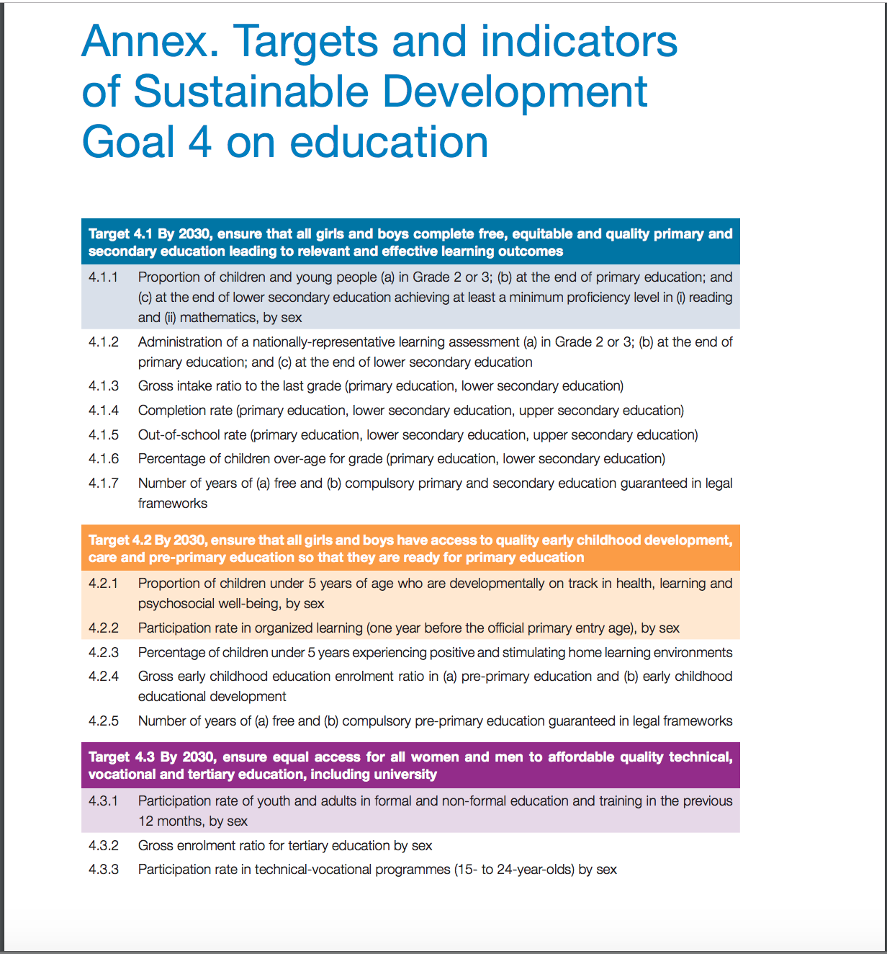

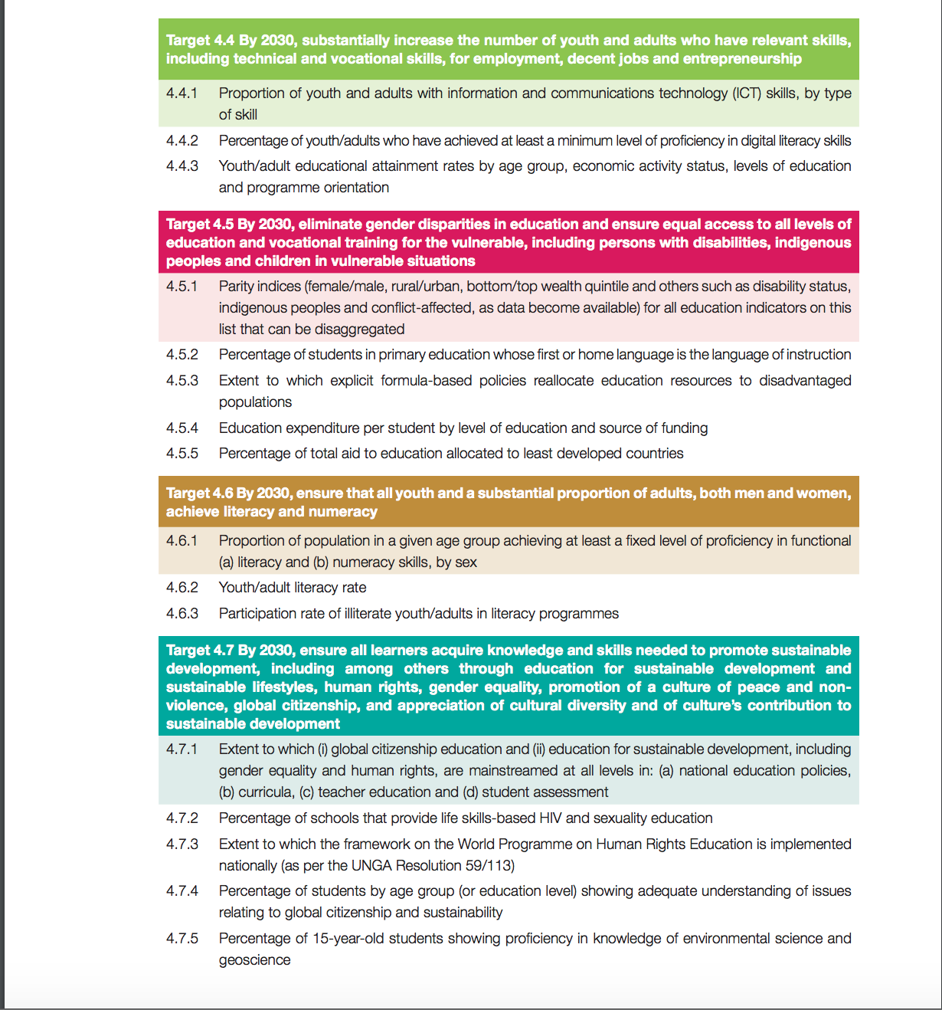

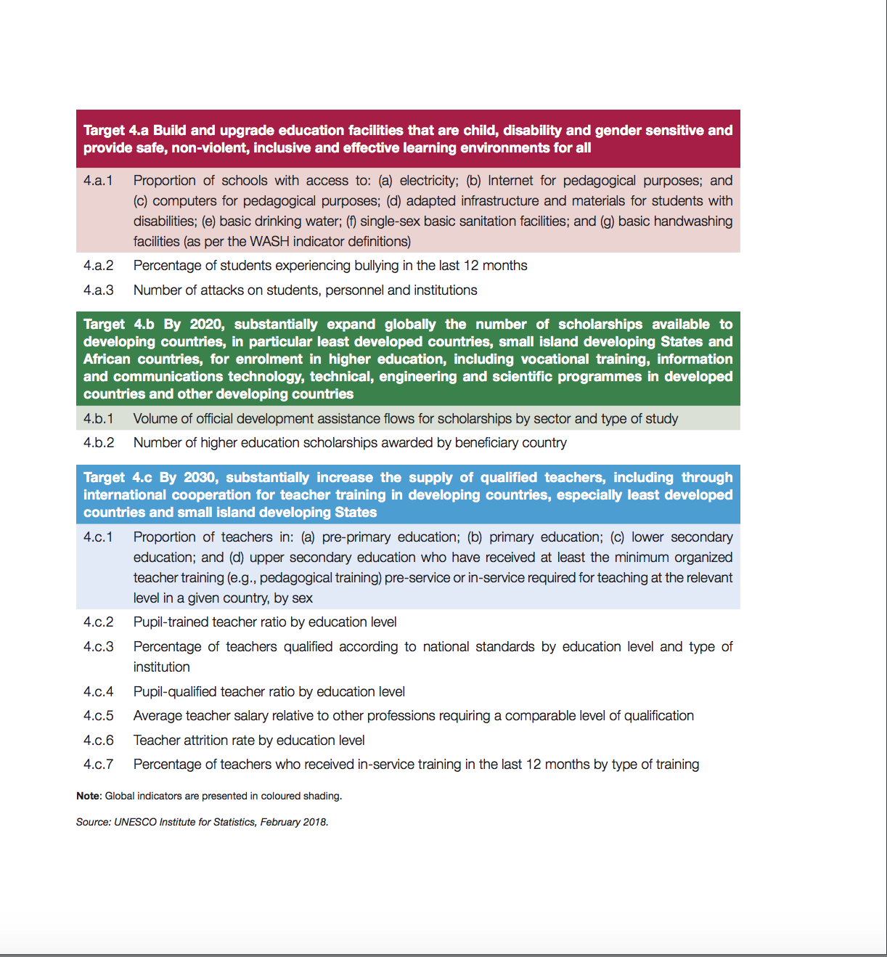

Annex 3 MDGs and Dakar Targets

A.1 Millennium Development Goals for Education (2000)
MDG 2 Achieve universal primary education Ensure that by 2015, children everywhere, boys and girls alike, will be able to complete a full course of primary schooling.

MDG 3 Promote gender equality and empower women Eliminate gender disparity in primary and secondary education, preferably by 2005, and in all levels of education no later than 2015.

A.2 Education for All Goals (2000)
Goal 1 Expanding and improving comprehensive early childhood care and education, especially for the most vulnerable and disadvantaged children.

Goal 2 Ensuring that by 2015 all children, particularly girls, children in difficult circumstances and those belonging to ethnic minorities, have access to, and complete, free and compulsory primary education of good quality.

Goal 3 Ensuring that the learning needs of all young people and adults are met through equitable access to appropriate learning and life-skills programmes.

Goal 4 Achieving a 50 per cent improvement in levels of adult literacy by 2015, especially for women, and equitable access to basic and continuing education for all adults.

Goal 5 Eliminating gender disparities in primary and secondary education by 2005, and achieving gender equality in education by 2015, with a focus on ensuring girls’ full and equal access to and achievement in basic education of good quality.

Goal 6 Improving all aspects of the quality of education and ensuring excellence of all so that recognised and measurable learning outcomes are achieved by all, especially in literacy, numeracy and essential life skills.

References

Burnett, N. (2012). ‘Will there be education goals after 2015? Education’s fragile position on the global agenda’. In: Commonwealth Education Partnerships 2012/13, pp. 25-26. Cambridge and London: Nexus Strategic Partnerships and Commonwealth Secretariat.

CREATE. (2011). Making rights realities: Researching educational access, transitions and equity. Brighton: Consortium for Research on Educational Access, Transitions and Equity. Retrieved 15 November 2012 from http://www.create-rpc.org/pdf_documents/Making-Rights-Realities-Keith-Lewin-September-2011.pdf

Commonwealth Secretariat (2012a) ‘Commonwealth Recommendations for the Post-2015 Development Framework for Education’. Background Paper. London: Commonwealth Secretariat.

Commonwealth Secretariat. (2012b). 18th Conference of Commonwealth Education Ministers (18CCEM) Mauritius Communiqué. London: Commonwealth Secretariat.
.
Commonwealth Secretariat. (2012c). 18CCEM Issues paper synopsis. London: Commonwealth Secretariat.

Commonwealth Secretariat. 2018. 20th Conference of Commonwealth Education Ministers (18CCEM) Proceedings Report, Nadi, Fiji. London: Commonwealth Secretariat.

Easterly, William. 2013. The Tyranny of Experts: Economists, Dictators and the Forgotten Rights of the Poor. New York: Basic Books.

Lewin, KM. (2012). Revisiting the Internationally Agreed Goals for education. Presentation given at the 18th Conference of Commonwealth Education Ministers, Mauritius, 30 August. Retrieved 7 November 2012 from http://www.create-rpc.org/pdf_documents/CCEM18KeithLewinRevisitingtheIAGsSummary.pdf

Lewin K. M. (2015) ‘Educational Access, Equity and Development: Planning to Make Rights Realities’. Fundamentals of Educational Planning 98. Paris: UNESCO.

Lewin K. M. (2017) ‘The Educational Challenges of Transition; Key Issues Towards 2030’. Washington, DC: Global Partnership for Education.

Lewin K M (2018) Learning matters and the World Development 2018. UKFIET Blog
https://www.ukfiet.org/2018/learning-matters-and-the-world-development-report-2018/

UIS (2017) UNESCO Institute of Statistics, Education Online Database. Montreal: UIS

UNECA (2012) UN Economic Commission for Africa. Addis Ababa, Ethiopia.

UNESCO (2016) Education for People and Planet: Creating Sustainable Futures for All. Paris, UNESCO

UNESCO (2017) Sustainable Development Goals: Learning Objectives. Paris: UNESCO.

UNESCO (2018) 11 Global Indicators for the SDGs: Cheat Sheet
https://www.sdg4education2030.org/cheat-sheet-sdg4-indicators-12-july-2018
http://uis.unesco.org/sites/default/files/documents/11-global-indicators-sdg4-cheat-sheet-2018-en.pdf

UN 2019 Global Assessment. Inter Governmental Science Policy Platform on Biodiversity and Ecosystems Services (IPBES) https://www.ipbes.net/

World Bank (2017) World Development Report 2018. Learning to Realize Education’s Promise. Washington, DC: World Bank.

This paper draws on the analysis and documentation generated in preparation of the 18th CCEM and 20th CCEM for its discussions of the CMGT. (Commonwealth Secretariat (2012 a, b and c) and Commonwealth Secretariat (2018).
More discussion of the development of the proposals is available in Commonwealth Secretariat 2012a Commonwealth Recommendations for the Post-2015 Development Framework of Education: Background Paper.
Attributed to Harold MacMillan probably apocryphally. MacMillan was UK Prime Minister when the first Commonwealth Minsters Conference took place sixty years ago in 1959 in Oxford.
Acknowledgements to UNESCO, IIEP for SDG 4 Summary

